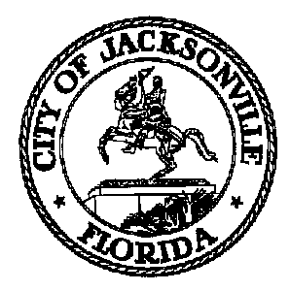
Taxation, Revenue and Utilization of
Expenditures (TRUE) Commission

Daniel Henry, Chair TRUE Commission
c/o Jeff Clements
Suite 425, City Hall
117 W. Duval Street
Jacksonville FL 32202
904-255-5137

TO: TRUE Commissioners

FR: Daniel Henry – Chair

RE: September 9, 2021 TRUE Commission Meeting Notice

The TRUE Commission will meet on Thursday, September 9, 2021 at 4:00 p.m. in Committee Room B, 1st floor, City Hall, for the purpose of hearing standing committee reports and discussing matters related to the City’s finances and operations. All interested parties are invited to attend. In-person attendance by members of the public is necessary to participate in public comment.

You may attend the meeting in-person at the Don Davis Room, but CDC guidelines will be adhered to due to COVID-19. Concurrent with the expiration of Mayor Curry's Emergency Executive Proclamation 2020-005, any member of the public entering City-owned public buildings may choose to wear a mask inside the building. City Council strongly encourages the use of masks for all employees and visitors, especially when social distancing at 6 feet (or more) is not possible. The Council will make masks available for visitors and the public if necessary.

Pursuant to the American with Disabilities Act, accommodations for persons with disabilities are available upon request. Please allow 1-2 business days' notification to process; last-minute requests will be accepted but may not be possible to fulfill. Please contact Disabled Services Division at: V (904) 255-5466, TTY (904) 255-5476, or email your request to KaraT@coj.net.

For further information contact Jeff Clements at jeffc@coj.net or 904-255-5137.

Jeff Clements, Council Research Division Posted 8.31.21 2:30 p.m.

